EEM Release Notes

for

Version 3.17 released as of

01/06/2018 11:58 AM

Table of Contents

1. Introduction 3

2. Compatible Products 3

3. Installation Steps 3

4. New Features 3

5. Bug Fixes 4

6. Known Problems and Workarounds 4

# Introduction

This document communicates the major new features, bug fixes and setup changes in this release of the EEM. It also documents known problems and workarounds.

# Compatible Products

This release has been tested on the following platforms and products:

* Windows OS 2012 on the Server
* Windows OS 7.0 on the Client
* MS SQL Server 2012
* Internet Explorer 11

# Installation Steps

* Backup the EEM Production Binaries for future use
* Download the Release rar files from the git hub.
* Stop the EEM Production Website on IIS
* Extract any one rar file which will automatically extract all required EEM binaries and related files.
* After successful extraction, copy the files to the EEM release location on the EEM server.
* Go to the Scripts\Upgrade folder in the released location and run Setup.cmd
* Restart the EEM Production Website on IIS

# New Features

* 1. **Feature Description:**

Externalize the end date for bugs based on the Teams and not be generic

**UI Changes:**

* + Days For Other Category Bugs and Days For Service Request fields are retired from the system preferences UI

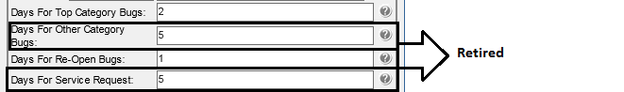

* + Days For "Task Type" Category Bugs field is introduced, you can setup no. of days for individual task type here. It contains list of bug types except top categories
  + Days For Service Request field's value will be automatically copied to Service Request task type and Days For Other Category Bugs field's value will be automatically copied to Default
  + If any of the task type value is not mentioned it will take Default value for end date calculation.

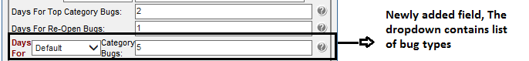

* + Please review all the values in system preference and click save

# Bug Fixes

* 1. **Bug Description:**

[Export to excel is not working in the request when we have sprint numbers and Program Increment](https://github.com/EagleShare/EEM/issues/11).

It was seen when the custom fields column is selected and export to excel is done in RT. Then it was not working because of the long description for custom fields was not handled. Its fixed now.

# Known Problems and Workarounds

None